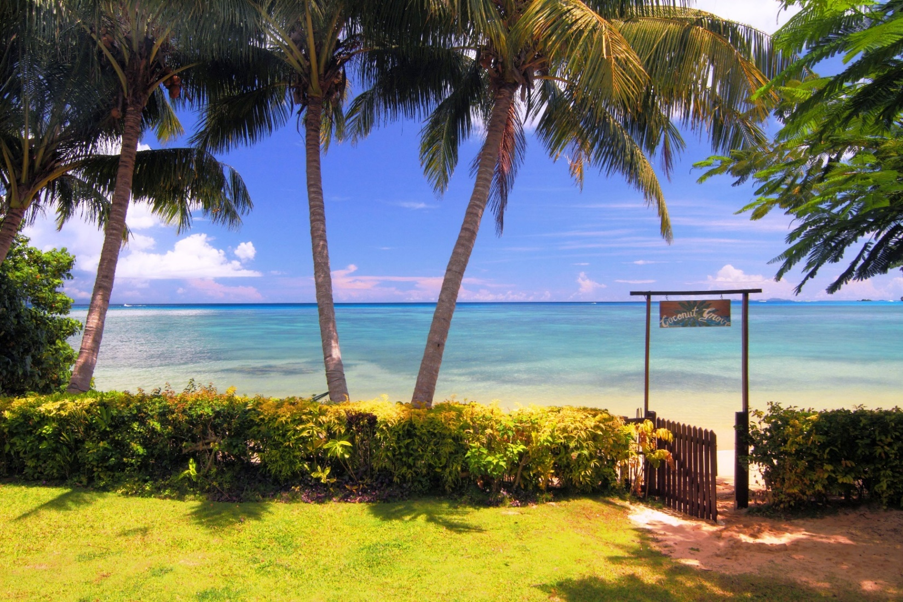

COCONUT GROVE BEACHFRONT COTTAGES
MEMORANDUM OF SALE

COCONUT GROVE LTD
P.O. #9M MATEI
TAVEUNI, FIJI ISLANDS
www.coconutgrovefiji.com
ronna@coconutgrovefiji.com
ph (679) 928 6780

SUMMARY
In March, 1993 Coconut Grove Beachfront Cottages opened its doors with a vision to provide travelers something unique on Taveuni.
Before we opened, there were no boutique properties in Matei, the northern side of Taveuni, in a middle price range. And since Matei was the tourist center of the island, there was also a definite need for a great restaurant.
We opened with just 3 cottages, all directly on the beach. We became the top property on the island, recognized by Frommers, Lonely Planet and later by Trip Advisor as the place people wanted to stay.
The owner has achieved this goal & Coconut Grove is recognized as being in the “Top 1% of all resorts in the world”
WHY IS COCONUT GROVE BEACHFRONT COTTAGES MORE VALUABLE THAN OTHER PROPERTIES FOR SALE IN FIJI?
1. It is located in Matei, the most desirable area of the island (think restaurants, gift shops, grocers, dive shops & the airstrip)
2. It is situated on 1 acre of freehold (titled) beachfront on an island where there is very little beach(ours is soft sand, not coral)
3. Average tenure of staff is over 10 years. The existing owner is off grounds 3 months of the year with the staff running the resort & quality maintained.
4. our “house reef” is known as the top house reef in the country (reference Helen Sykes, Fiji’s Marine Biologist)
5. We have won 23 awards in just 9 years on Trip Advisor
6. With ½ acre of undeveloped freehold beachfront adjoining, there is potentially the chance to more than double (add 3-5 cottages) or triple your income (instead add 2 5 star luxury 2 bedroom beachfront villas)

CURRENT COMPANY ASSETS
>3 separate beachfront cottages with attached bathrooms & 1 normal shower, & in 2 of them an outdoor “Honeymoon Shower”
>1/2 acre of undeveloped beachfront adjoining
>Central building containing the oceanfront restaurant with expansive views for dining,2 bedrooms, 3 bathrooms, gift shop & kitchen
>Multi-award winning resort for 9 years in a row.
>Turn key systemized operational base
>Award winning staff of 9 with an average of over 10 years employment.
> 3.5 star (self rated)
>24 hour electricity provided via:
2 of 13.9 Kva Lister Generators
2 brand new outback invertors
16 deep cycle sealed gel batteries
4 solar panels
>Government water line
>2 beach tiki huts for private massage & candlelight dinner
>Toyota Land Cruiser with 130,000 miles
>Battery powered Club Car golf cart for short runs
>3 fully outfitted kayaks down on the beach
>Hammocks & chaise lounges throughout
>4 professionally trained massage therapists
>2 dogs & 1 cat for petting & attention

OPPORTUNITY FOR EXPANSION
The ½ acre adjoining Coconut Grove Beachfront Cottages has doubled the size of the resort.
This ½ acre of additional freehold beachfront land affords the new owner the opportunity to double or even triple the income

SITE-LOCATION-ACCESSIBILTY
The resort is located just across the road from the airstrip, where 5 prop planes arrive every day, allowing delivery of goods from the main island on the same day.
In addition, guests are not subject to an arduous journey in order to reach the property. If coming on the morning flight they are able to be on the beach by 9:00 A.M.
Taveuni is well serviced with domestic flights every day.

MARKETING & BRAND POSITION
Coconut Grove is internationally recognized, offering a private & unique opportunity for couples to have complete privacy. (Children over 8 are welcome) And with Taveuni’s recognition as the top destination for eco-tourism we are in a position to maintain the same degree of success in the future.

TAVEUNI ASSESTS
>The world famous Rainbow Reef rated 3rd finest in the world amongst divers & snorkelers
>Excellent deep sea fishing
>Bouma Waterfalls
>Lavena Coastal Walk
>Waitabu Marine Park
>Lake Tagimaucia
>The home of the famous “Orange Dove”

GENERAL MARKET CHARACTERISTICS
There is a huge international demand for vacations that are “active” with high quality activities & experiences. Fiji is the ideal location for such products with pristine, isolated natural resources, the friendliest people on earth & a rating as the 3rd safest country in the world.

AWARDS

Featured on page 683 of “1000 Places to see Before you Die”
Winner of 2018 Trip Advisor Award “8th Most Romantic”
Winner of 2017 Trip Advisor Award “9th Most Romantic” & “3rd Best Service”
Winner of 2016 Trip Advisor Award “5th Best Value for Money” & “1 Best Service”
Winner of 2015 Trip Advisor Award “7th Best Value for Money” & “4th Most Romantic”
Winner of 2014 Trip Advisor Award “4th Most Romantic” & 4th “Best Bargain a& Hidden Gem”
Winner of 2013 Trip Advisor Award “5th Best Service” & “4th Most Romantic”
Winner of 2012 Trip Advisor Award “4th Best Service” & “5th Most Romantic”
Winner of 2011 Trip Advisor Award “7th Best Service” & “5 Best Bargain & Hidden Gem”
Winner of 2010 Trip Advisor Award “4th Most Romantic” & “4 Best Service”
Winner of 2009 Trip Advisor Award”9th Best Service”

FINANCIALS
Full audited financial statements will be supplied on a site inspection after signing a confidentiality agreement.
Sale price: $1,300,000 U.S.

CONTACT:
Director & Owner: Ronna Goldstein
Email: ronna@coconutgrovefiji.com
Mobile: (679) 928 6780
Land line (679) 888 0328
Website: www.coconutgrovefiji.com

QUESTIONS AND ANSWERS:
Why are you selling the resort?
I am 72. I have been away from friends and family for nearly 32 years. It is time to head back

Would you consider vendor financing?
With a down payment of 50% I am happy to finance at the prevailing bank rate for 5 years

Do you want overseas settlement of the sale?
I do not necessarily require overseas settlement. Funds paid as part of any sale can be held by solicitors in an international escrow account in Fiji

What is the commitment deposit?
The commitment deposit is $100,000 U.S.

Is it refundable?
The commitment deposit is non-refundable under any circumstances other than vendor electing to pull out of sale in breach of Purchase Agreement

Would you agree to a no-competition agreement?
Yes. I will be returning to family and friends in the U.S.

Would you consider a handover/transition period?
I think it is completely necessary in order to facilitate the transition

Would you share your marketing strategies & introduce new owners to wholesalers?
Absolutely. New owners would have full access to anything I have implemented in order to be so successful

Would past guest contact list be available?
Completely

Would you be available post sale for advice and historic information?
I would be completely available

Would you consider staying on in a management role?
Yes, I would be very interested part time

Would the residence be left furnished?
The sale would include all furniture & fittings as well as appliances (5 freezers & fridge, 2 dryers, 2 washers, stove, everything)
I would want to take my personal items i.e. paintings & nic nacs in my room

